

Faculty of Engineering & Technology

Semester End Examination Question Paper – B. Tech.

Department: Computer Science and Engineering
Course: B. Tech. in Computer Science and Engineering
Semester/Batch: 6th / 2018
Course Code: 19CSL317A
Date: 28/07/2021
Course Title: Web architecture and Application development laboratory

Semester End Examination – Practical/Laboratory

INSTRUCTIONS TO STUDENTS:
1. Answer THE PARTICULAR QUESTION assigned to you by the Examiner
2. Use only SI units
3. Missing data may be appropriately assumed
4. Send the scanned answer script to harikrishna.cs.et@msruas.ac.in and upload the same pdf in RUAS portal

Maximum Duration: 3 Hours Maximum Marks: 50

Scenario:
An online clothing store has several products such as polo-tees, rain coats, riding jackets, formal shirts and blazers. The clothing attributes are item Id, item name, item description and item cost.

Design a database and create a web application with HTML user interface connecting the database using PHP. The application displays the database details in HTML page in a table format, where the item cost less than INR 879 are listed in the HTML table as result.

You are required to document design and implementation including:
  - Development of ER diagram and class diagram for the above scenario considering a registered user with valid attributes for both the diagrams
  - Creation of database
  - Source code with documentation
  - Result screenshots
  - Analysis and discussion

Sl. No. | Item | Maximum Marks | Marks Obtained
1 | ER and Class diagram for the scenario | 10
2 | Database + Source code and documentation + Results + Analysis and Discussion  b + c + d + e | 8 + 20 + 5 + 7 = 40
 | Total | 50
 | Final Score | 25

Solution:
- ER diagram and Class diagram
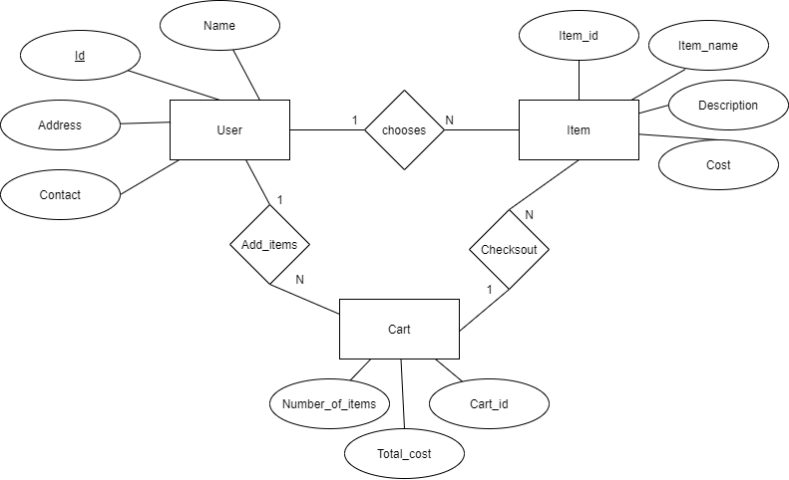
Figure 1 ER diagram with 3 entities and respective attributes and relations

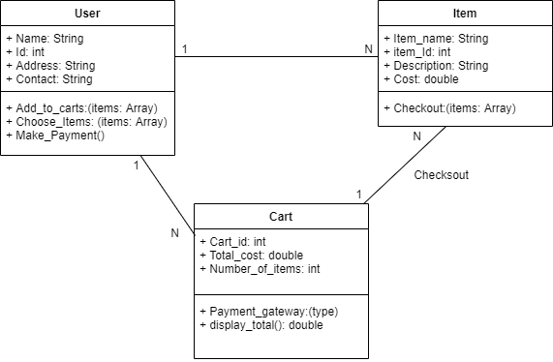
Figure 2 Class diagram with 3 entities and respective attributes and relations

- Creation of the database
- Login to MySQL-server with user and password
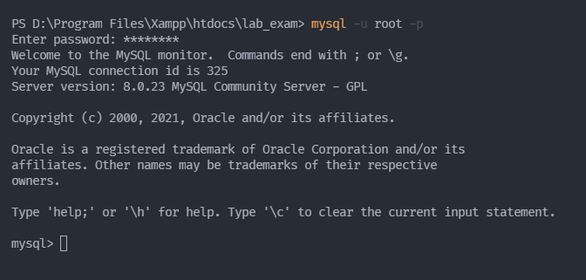
Figure 3 login to Mysql

- Create the database and use the database
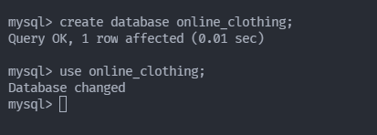
Figure 4 creating database and using it
- Create the table items
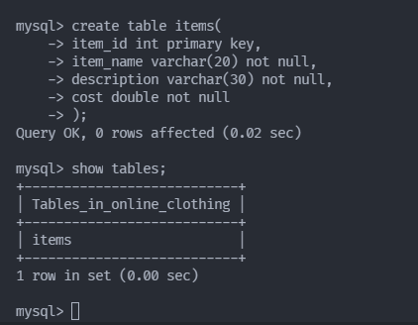
Figure 5 creating table 'items'
- Add values in table items
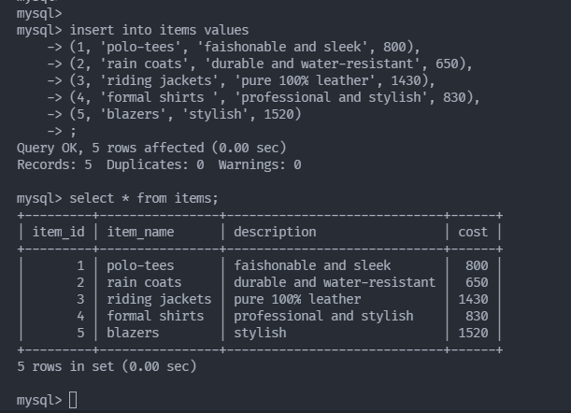
Figure 6 adding values in table 'items'

- Query of items which cost less than 879 ₹
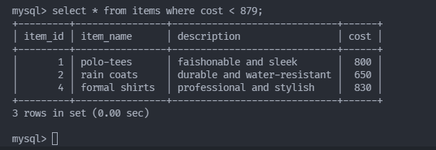
Figure 7 items which cost less than 879 rupees
- Source Code with documentation

<html>
<head>
<meta charset="UTF-8">
<title> Online Clothing Store </title>
<link rel="stylesheet" type="text/css" href="style.css">
</head>
<body>
<h1> Welcome to Online Clothing Store</h1>
<br/>
<h4> The items are listed below</h4>

<?php
// connecting to mysqli client using username and password
$con = mysqli_connect("localhost","root","subhendu","online_clothing");

// handling error for database connection
if(mysqli_connect_errno())
{ echo "DATABASE ERROR"; }

// query to fetch items from the database whose cost is less than 879
$query="select * from items where cost < 879";

// fetching the result of the query
$result=mysqli_query($con,$query);

// displaying the result
echo"<table border=3>
<tr>
<th> ID</th>
<th> Name</th>
<th> Description</th>
<th> Cost (in ₹)</th>
</tr>";
if (mysqli_num_rows($result)>1)
{
while($row=mysqli_fetch_assoc($result))
{
echo'<tr>';
echo '<td>'.$row['item_id'].'</td>';
echo '<td>'.$row['item_name'].'</td>';
echo '<td>'.$row['description'].'</td>';
echo '<td>'.$row['cost'].'</td>';
echo'<tr>';
}
}?>

</body>
</html>

- Results
- Starting up Xampp for Apache Server
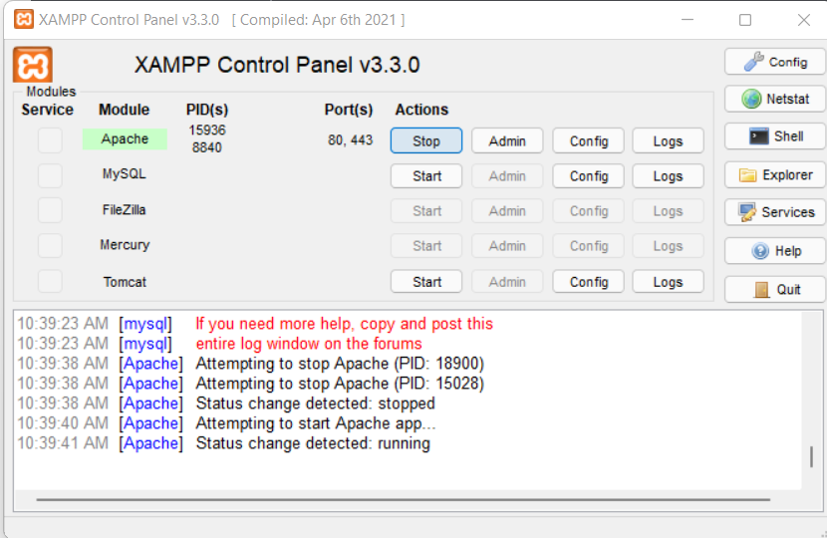
Figure 8 Xampp for using Apache

- In browser opening localhost/lab_exam/index.php
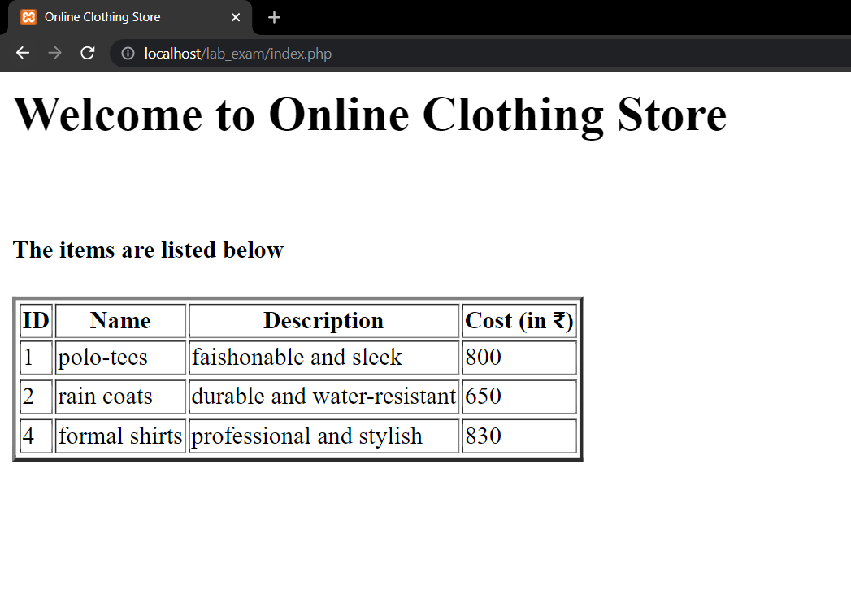
Figure 9 PHP page served with Apache

- Analysis and Discussion
PHP is a server-side scripting language that is embedded in HTML. It is used to manage
dynamic content, databases, session tracking, even build entire e commerce sites. It is integrated with a number of popular databases, including MySQL, PostgreSQL.

In this lab we displayed the database details in HTML page in a table format, where item cost less than 879 ₹. All the code is executed in PHP header tag.
We used mysqli (an extension of php for using MySql database) for connecting to Mysql server and fetching result according to our query. After fetching the result, we displayed it using HTML table tag.

